ELISA READER
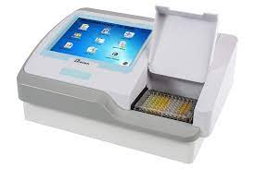
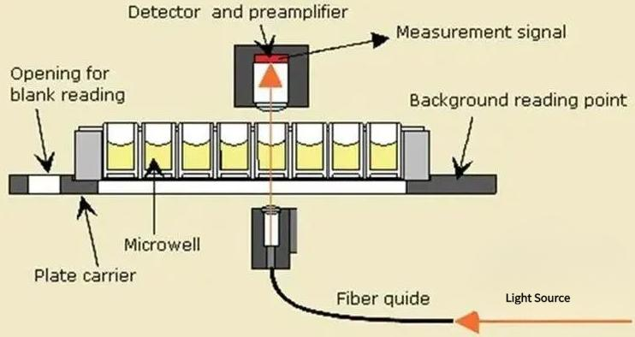
Introduction
ELISA (enzyme-linked immune-sorbent assay) is a plate-based assay technique designed for detecting and quantifying peptides, proteins, antibodies and hormones.
In an ELISA, an antigen must be immobilized to a solid surface and then complexed with an antibody that is linked to an enzyme.
Detection is accomplished by assessing the conjugated enzyme activity via incubation with a substrate to produce a measureable product.
The most crucial element of the detection strategy is a highly specific antibody-antigen interaction.
ELISAs are typically performed in 96-well (or 384-well) polystyrene plates, which will passively bind antibodies and proteins. It is this binding and immobilization of reagents that makes ELISAs so easy to design and perform.
Having the reactants of the ELISA immobilized to the micro plate surface makes it easy to separate bound from non-bound material during the assay. This ability to wash away nonspecifically bound materials makes the ELISA a powerful tool for measuring specific analytes within a crude preparation.
General ELISA Procedure
ELISA begins with a coating step, in which the first layer, consisting of a target antigen or antibody, is adsorbed onto a 96-well polystyrene plate.
This is followed by a blocking step in which all unbound sites are coated with a blocking agent. Following a series of washes, the plate is incubated with enzyme-conjugated antibody.
Another series of washes removes all unbound antibody. A substrate is then added, producing a calorimetric signal. Finally, the plate is read.
Because the assay uses surface binding for separation, several washes are repeated in each ELISA step to remove unbound material. During this process, it is essential that excess liquid is removed in order to prevent the dilution of the solutions added in the next assay step. To ensure uniformity, specialized plate washers are often used.
N/B: ELISAs can be quite complex and include multiple intervening steps, especially when measuring protein concentration in heterogeneous samples such as blood. The most complex and varying step in the overall process is detection, where multiple layers of antibodies can be used to amplify signal.
Elisa Reader Machine
The micro plate reader also known as photometric micro-plate reader or ELISA reader is a specialized spectrophotometer designed to read results of the ELISA test (a technique used to determine the presence of antibodies or specific antigens in samples).
The technique is based on the detection of an antigen or antibodies captured on a solid surface using direct or secondary, labeled antibodies; producing a reaction whose product can be read by the Elisa reader.
Operation principles of the Reader
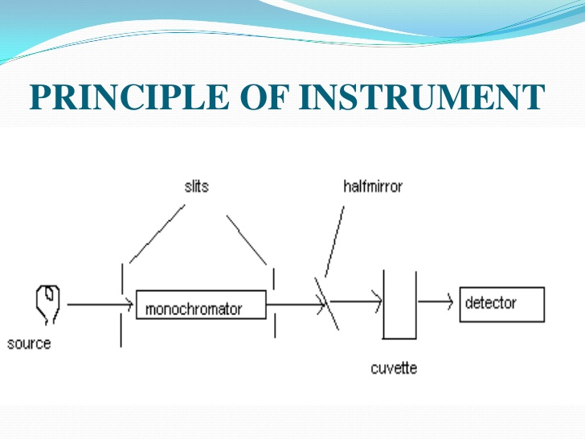

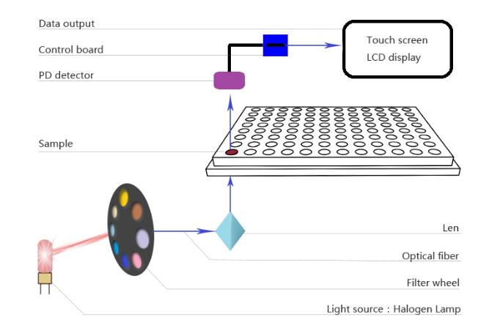
The micro plate reader is a specialized spectrophotometer and unlike the conventional spectrophotometer which facilitates readings on a wide range of wavelengths, the micro plate reader has filters or diffraction gratings that limit the wavelength range to that used in ELISA, generally between 400 to 750 nm (nanometers).
Some readers operate in the ultraviolet range and carry out analyses between 340 to 700 nm.
The optical system exploited by many manufacturers uses optic fibers to supply light to the micro plate wells containing the samples.
The light beam, passing through the sample has a diameter ranging between 1 to 3 mm.
A detection system detects the light coming from the sample, amplifies the signal and determines the sample’s absorbance.
A reading system converts it (absorbance) into data allowing the test result interpretation. Some micro plate readers use double beam light systems.
Test samples are located in specially designed plates with a specific number of wells where the procedure or test is carried out. Plates of 8 columns by 12 rows with a total of 96 wells are common. There are also plates with a greater number of wells.
The location of the optical sensors of the micro plate reader varies depending on the manufacturers; these can be located above the sample plate, or directly underneath the plate’s wells.
N/B: Nowadays, micro plate readers have controls regulated by microprocessors connection interfaces to information systems; quality and process control programs, which by means of a computer, allow complete test automation.

Summary of Operation Principle
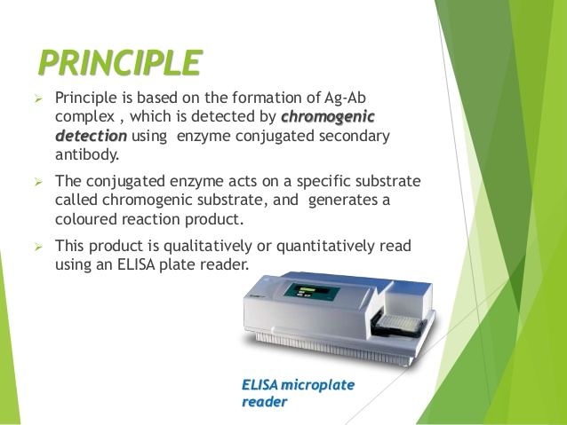

Installation Requirements of the Reader
1. A clean and dust free environment.
2. A stable work table that is away from equipment that vibrates (centrifuges, agitators).
It should be of a suitable size so that there is working space at the side of the micro plate reader.
The required complementary equipment for conducting the technique (ELISA) is: washer, incubator, dispenser and computer with its peripheral attachments.
3. An electrical supply source, which complies with the country’s norms and standards. In the country like America for example, 110 V and 60 Hertz frequencies is generally used, whereas other regions of the World use 220-240V, 50/60HZ.
Repair/Maintenance of Elisa Machine
Daily Maintenance
1. Review that optical sensors of each channel are clean. If dirt is detected, clean the surface of the windows of the light emitters and the sensors with a small brush.
2. Confirm that the lighting system is clean.
3. Verify that the reader’s calibration is adequate. When the daily operations begin, let the reader warm up for 30 minutes. Next, do a blank reading and then read a full plate of substrate.
The readings must be identical. If not, invert the plate and repeat the reading in order to determine if the deviation originated in the plate or the reader.
4. Examine the automatic drawer sliding system. It must be smooth and constant.
Quarterly Maintenance
- Verify the stability of the lamp.
- Clean the detectors’ optical systems and the lighting systems.
- Clean the plate drawer.
- Verify the alignment of each well with the light emission and detection systems.
Calibration of the Micro plate Reader
Calibration of a micro plate reader is a specialized process which must be executed by a technician or trained engineer following the instructions provided by each manufacturer.
In order to do the calibration, it is necessary to have a set of grey filters mounted on a plate of equal geometric size to those used in the analyses.
Manufacturers provide these calibration plates for any wavelength the equipment uses.
Calibration plates are equipped with at least three pre-established optic density values within the measurement ranges; low, medium, and high value.
In order to perform the calibration, the following process is followed;
1. Place the calibration plate on the equipment.
2. Carry out a complete reading with the calibration plate. Verify if there are differences in the readings obtained from well to well. If this is the case, invert the plate (180°) and repeat the reading to rule out that differences are attributed to the plate itself.
In general, it is accepted that the instrument does not need further calibration if the plate results are as expected at two wavelengths.
3. Verify if the reader requires calibration. If so, proceed with the calibration following the routine outlined by the manufacturer, verifying that the reading’s linearity is maintained as rigorously as possible.
4. If the instrument does not have a calibration plate, verify it by placing a coloured solution in the wells of a plate and immediately carry out a complete reading.
Then invert the plate 180° and read the plate again. If both readings display identical, average values in each row, the reader is calibrated.
Common Problems on Eliza Reader Machine and Remedies
- The reader gives a reading that does not make sense.
Cause and Remedy
The illumination lamp is out of service; replace the lamp with a new one with the same characteristics as the original.
- The reader’s readings vary from row to row.
Cause and Remedy
- Dirty optical sensors, clean the sensors.
- The illumination system’s lenses or parts are dirty; clean the lighting system’s lenses.
- Lack of calibration in one or more channels; verify the calibration of each one of the channels.
- The reader displays high absorbance values.
Cause and Remedy
- Reagents expired and/or incorrectly prepared, check to see if the TMB is colorless and the preparation adequate.
- Contamination with other samples, repeat the test verifying the labeling, the washer and how the pipette was used.
- Incorrect wavelength filter, verify the recommended wavelength for the test and adjust if it is incorrect.
- Insufficient or inefficient washing, verify the washing method used using an appropriate quality control test.
- Very long incubation time or very high temperature, check incubation times and temperatures.
- Incorrect sample dilution, check process for sample dilution.
- Some reagent was omitted; verify that the test has been carried out according to the established procedure.
- The reader displays low absorbance values.
Causes and Remedy
- Very short incubation time and very low temperature check temperatures and incubation times.
- The reagents were not at room temperature; check that the reagents are stable at room temperature.
- Excessive washing of the plate, Adjust the washing process to what the test manufacturers indicate.
- Incorrect wavelength filter, Verify the wavelength selected and Use wavelength recommended for the test.
- Expired or incorrectly prepared reagents, Check the used reagents and Test the dilutions.
- A reagent was omitted. Verify that the test was done according to the established procedure.
- Incorrect selected or dirty plate. Verify the type of plate used. Prepare a new plate and repeat the test.
- The plate wells have dried up. Change the manner in which the plate is washed.
- The plate is incorrectly placed or is seated unevenly in the reader. Check the placement of the plate. Repeat the reading.
- The reader displays unexpected variation in the optical density readings.
Cause and Remedy
- The reader’s lamp is unstable. Replace the lamp with one that has similar characteristics as the original.
- Misaligned light beam.
Cause and Remedy
- The reader was transferred or moved without using the necessary precautions. Call the specialized service technician.
- The light source – lamp – has been changed and the replacement has not been installed or aligned correctly. Verify its assembly and alignment.

MICRO-PLATE/ELIZA WASHER
The micro plate washer or “plate or ELISA washer” is designed to perform washing operations required in the ELISA technique. The micro plate washer performs the washing of the ELISA plate’s wells during the different stages of the technique.
Operation Principles
The micro plate washer has been designed to perform washing operations in the ELISA technique. The equipment possesses at least, the following subsystems which vary depending on the manufacturer’s design.

- Control subsystem
Generally, the washer is controlled by microprocessors allowing programming and controlling steps to be performed by the washer such as: number of washing cycles 2 (1–5); expected times; supplying and extracting pressures; plate format (96–384 wells); suction function adjustment according to the type of well 3 (flat bottom, V bottom or rounded bottom or strips used); volumes distributed or aspirated; the soaking and agitation cycles, etc.
- Supply subsystem
Supply subsystem comprises a reservoir for the washing solution; one or several pumps; usually a positive displacement type syringe and a dispenser head that supplies the washing solution to the different wells by means of needles.
The head usually comes with eight pairs of needles for washing and aspirating simultaneously the wells of the same row (the supply and extraction sub-systems converge on the head).
There are models with twelve pairs of needles and others that conduct the washing process simultaneously in all the wells. Some washers offer the possibility of working with different types of washing solutions, performing the solution changes according to the program entered by the operator.
- Extraction or suction system
This requires a vacuum mechanism and a storage system for gathering the fluids and waste removed from the wells. The vacuum may be supplied by external and internal pumps.
Extraction is done by a set of needles mounted on the washer/dryer’s head. The number of needles varies from one to three according to the washer model used. If it uses only one needle, the washing and extraction operation is done with this single needle. If it uses two needles, one is used for supplying the washing solution and the other for extraction. If it uses three needles, the first is used for supplying the washing solution, the second for extraction and the third for controlling (extracting) any excess volume in the well. Generally, the extraction needle is longer than the supply needle, which enables it to advance (vertically) up to a height ranging between 0.3 and 0.5 mm from the bottom of the well.
- Advance subsystem.
This is composed of a mechanism which moves the supply and extraction head horizontally to reach each well in the ELISA plate. When the horizontal movement to the following row occurs, there is a vertical movement towards the well to dispense or extract the washing solution. There are washers which carry out these operations in a simultaneous manner.

